
These tasks will help you prepare a piece of writing to enter the

Orwell Youth Prize 2025, on the theme of ‘Freedom is…’

LESSON 2: Toads and freedom
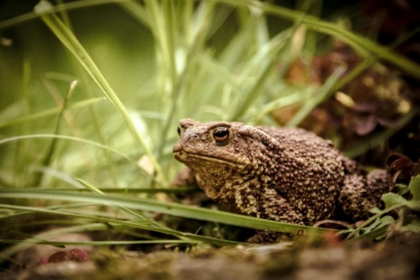
Orwell wrote about the things that mattered to him – and these weren’t always obviously political or serious topics. For example, his essay ‘Some Thoughts on the Common Toad’ talks about toads in Springtime (and how much Orwell appreciates seeing them) to make a serious point about individual freedom, and enjoying the little things in life – even when the world can seem a bit bleak.
TASK ONE: How does Orwell explore the freedoms we all have, in spite of ‘the dictators [and] the bureaucrats*’ by writing about a small, everyday creature?
First, read the full extract. Then, work through the questions below, which will help you think about how Orwell uses language and structure to explore his ideas.
- In paragraph 1, how does Orwell describe the natural world and the human world together? Try and pick out at least three quotes and explain how Orwell is using language to create an image in the reader’s mind.
- In paragraph 2, what reasons does Orwell give for the Spring seeming ‘miraculous’? How does Orwell use language and sentence structure to describe this ‘miracle’?
- In paragraphs 3 and 4, Orwell uses several rhetorical questions. How does the language Orwell use here help to engage the reader?
- In paragraph 5, what makes Orwell’s final reflections a satisfying ending?
- Your conclusion: how has Orwell structured or organised the piece overall to make it entertaining?

TASK TWO: Your Common Toad
- Orwell chose to focus on toads – but what small, everyday thing reminds you of the freedom we all have as humans to appreciate the world around us? It could be an animal or insect or bird, the rain, a smell, a sound, a food, a place… Extra points if, like the toad, it’s something which doesn’t normally get a “boost from poets”!
- Orwell talks about the “miracle” of Spring. What is miraculous or wonderful about your small everyday thing – which not everyone might notice?
- Who or what might try to stop you from enjoying this small thing? Orwell talks about dictators and bureaucrats*; atom bombs and lies…
- Write a short description describing how you experience or interact with this small thing. How can it bring a feeling of freedom and enjoyment, in spite of upheaval and issues going on in the world around you?
From Some Thoughts on the Common Toad
I mention the spawning of the toads because it is one of the phenomena of Spring which most deeply appeal to me, and because the toad, unlike the skylark and the primrose, has never had much of a boost from poets. But I am aware that many people do not like reptiles or amphibians, and I am not suggesting that in order to enjoy the spring you have to take an interest in toads. There are also the crocus, the missel thrush, the cuckoo, the blackthorn, etc. The point is that the pleasures of spring are available to everybody, and cost nothing. Even in the most sordid street the coming of spring will register itself by some sign or other, if it is only a brighter blue between the chimney pots or the vivid green of an elder sprouting on a blitzed site. Indeed it is remarkable how Nature goes on existing unofficially, as it were, in the very heart of London. I have seen a kestrel flying over the Deptford gasworks, and I have heard a first-rate performance by a blackbird in the Euston Road. There must be some hundreds of thousands, if not millions, of birds living inside the four-mile radius, and it is rather a pleasing thought that none of them pays a halfpenny of rent.
As for Spring, not even the narrow and gloomy streets round the Bank of England are quite able to exclude it. It comes seeping in everywhere, like one of those new poison gases which pass through all filters. The spring is commonly referred to as “a miracle,” and during the past five or six years this worn-out figure of speech has taken on a new lease of life. After the sort of winters we have had to endure recently, the spring does seem miraculous, because it has become gradually harder and harder to believe that it is actually going to happen. Every February since 1940 I have found myself thinking that this time Winter is going to be permanent. But Persephone, like the toads, always rises from the dead at about the same moment. Suddenly, towards the end of March, the miracle happens and the decaying slum in which I live is transfigured. Down in the square the sooty privets have turned bright green, the leaves are thickening on the chestnut trees, the daffodils are out, the wallflowers are budding, the policeman’s tunic looks positively a pleasant shade of blue, the fishmonger greets his customers with a smile, and even the sparrows are quite a different colour, having felt the balminess of the air and nerved themselves to take a bath, their first since last September.
Is it wicked to take a pleasure in Spring and other seasonal changes? To put it more precisely, is it politically reprehensible, while we are all groaning, or at any rate ought to be groaning, under the shackles of the capitalist system, to point out that life is frequently more worth living because of a blackbird’s song, a yellow elm tree in October, or some other natural phenomenon which does not cost money and does not have what the editors of left-wing newspapers call a class angle? There is no doubt that many people think so…
…Certainly we ought to be discontented, we ought not simply to find out ways of making the best of a bad job, and yet if we kill all pleasure in the actual process of life, what sort of future are we preparing for ourselves? If a man cannot enjoy the return of Spring, why should he be happy in a labour-saving Utopia? What will he do with the leisure that the machine will give him? I have always suspected that if our economic and political problems are ever really solved, life will become simpler instead of more complex, and that the sort of pleasure one gets from finding the first primrose will loom larger than the sort of pleasure one gets from eating an ice to the tune of a Wurlitzer. I think that by retaining one’s childhood love of such things as trees, fishes, butterflies and – to return to my first instance – toads, one makes a peaceful and decent future a little more probable, and that by preaching the doctrine that nothing is to be admired except steel and concrete, one merely makes it a little surer that human beings will have no outlet for their surplus energy except in hatred and leader worship.
At any rate, spring is here, even in London N.1, and they can’t stop you enjoying it. This is a satisfying reflection. How many a time have I stood watching the toads mating, or a pair of hares having a boxing match in the young corn, and thought of all the important persons who would stop me enjoying this if they could. But luckily they can’t. So long as you are not actually ill, hungry, frightened or immured in a prison or a holiday camp, Spring is still Spring. The atom bombs are piling up in the factories, the police are prowling through the cities, the lies are streaming from the loudspeakers, but the earth is still going round the sun, and neither the dictators nor the bureaucrats, deeply as they disapprove of the process, are able to prevent it.
First published in Tribune, 12 April 1946. From the Complete Works, XVIII, 2970, p. 238.

