These tasks will help you prepare a piece of writing to enter the
Orwell Youth Prize 2024, on the theme of ‘HOME’

LESSON 1: IN DEFENCE OF ENGLISH COOKING
“It is commonly said, even by the English themselves, that English cooking is the worst in the world.”
‘In Defence of English Cooking’ by George Orwell, published in the Evening Standard, 15th December 1945

Orwell wrote about the things that mattered to him – and these weren’t always obviously political or serious topics. For example, his essay ‘In Defence of English Cooking’ is all about food – and while he makes a serious point, he gives the reader a laugh.
Read the full text here.
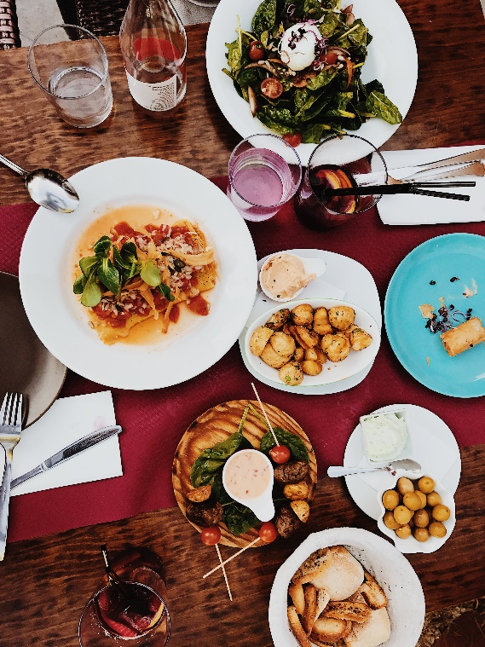
Food and home are often very closely linked. Here are some prompts, inspired by ‘In Defence of English Cooking’, to help you get started coming up with ideas and writing a piece about what food and home mean to you:
1) Orwell picks out a selection of English foods he particularly loves. What would be on your list of most treasured home-foods, which you’d miss if you lived somewhere else? Are there foods/combinations of foods which are special to your family/community? How would you describe them to someone who had never tried them?

2) When writing persuasively, it’s important to show you’ve considered the other side of the argument. Orwell includes the counterargument in his ‘Defence’ of English cooking: “It is commonly said, even by the English themselves, that English cooking is the worst in the world.”
Imagine someone is arguing that the foods you love are ‘the worst in the world’. How would you convince them that they’re actually delicious?

3) What foods do you associate with your home?
- Your household/family – e.g. grandad’s curry, mum’s Sunday roast, sister’s cookies…
- Comfort food – a food which helps you relax at home
- Your town/city/county/neighbourhood – local delicacies you might not get elsewhere (e.g. Cornish pasties, Welsh cakes, haggis, Dorset knobs – look them up!)
- Your country – this could include both where you live now, and anywhere else you have lived (e.g. if you were born in/spent some years in a different country), or where your parents/grandparents lived.

4) Plan to describe your favourite, homely meal to make your reader’s mouth water.
(15 minutes total)

This could be any one of the four foods from above – your household/family food, your comfort food, your town/city/county food, your country’s food.

3 steps:

1) MINDMAP your feelings about this food in five areas, one for each sense. (5 minutes)

2) Next, move to the PLAN. Decide the best order in which to write your description – which of the senses will you start with? Number them – this will be your sequence. (5 minutes)

3) Now think of a good sentence to LINK each paragraph to the next and write each one down. It can come at the end of the old paragraph or the start of the new one.
(5 minutes)

