You will work through some tasks to help you prepare a piece of WRITING TO ENTER THE ORWELL YOUTH PRIZE, ON THE THEME OF

‘A NEW DIRECTION: STARTING SMALL’

LESSON 2 – reading George Orwell’s Wonder Walk: Some Thoughts on the Common Toad – and deciding what makes it good writing
- Reading or listening

Read the full text here:
https://www.orwellfoundation.com/the-orwell-foundation/orwell/essays-and-other-works/some-thoughts-on-the-common-toad/
Or listen to Orwell’s son and great grandson read it! It takes 10 minutes – 3 minutes intro and 7 minutes for the essay, which is a little bit shortened. https://www.youtube.com/watch?v=P2tMs3ZZiEM

- Thinking and writing:
How does Orwell make a good piece of writing out of a small, everyday creature? (allow up to 45 minutes)
Build your answer by writing the 6 paragraphs below. For each one, use a quote from the numbered paragraph in Common Toad. (You will need to number the 8 paragraphs!)

- How does Orwell use language at the start of the essay to make the most of the toad emerging in Paragraph 1?
- Orwell is not famous for comedy, but he has a dry sense of humour. How does he use funny description in Paragraph 3?
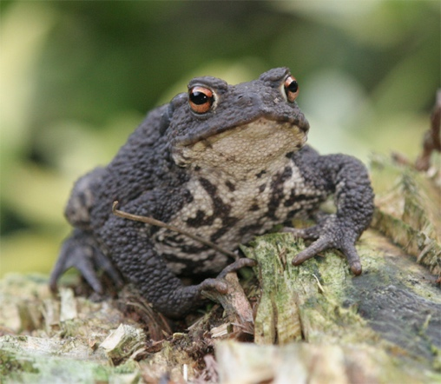
- Orwell refers to a ‘worn-out figure of speech’. How does he make everyday language feel original in Paragraphs 4-5?
- Rhetorical questions are among the most over-used devices. What makes the two rhetorical questions effective in Paragraph 6?
- What makes Orwell’s closing reflection a satisfying ending? Paragraph 8.
- Your conclusion: how has he structured or organised the piece overall to make it entertaining? Now you have finished!

Skills? *This will help you deepen your response to non-fiction and your own technique in writing it*

